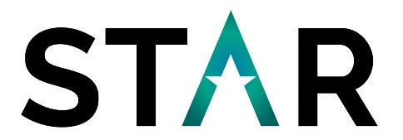
Social Value Case Study
Lift Maintenance, Servicing, and Repair
What was the project?  Adult Care is responsible for approximately 180 stair lifts, step lifts and vertical lifts provided for disabled service users.  Winning Bidder: Appointed via an open tender process  These lifts were funded through DFG and as a condition of installation, the Council required the service users to sign over ownership of the lifts to the council. Following installation, the Council became the owner of each stair lift and took full responsibility for insuring and maintaining it whilst in use, also committing to remove it when no longer required and make good the property. | 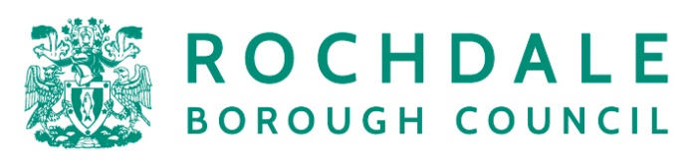
Outcomes

• Create 1 new job (minimum) in the local economy from within the Rochdale region
• Create 1 apprenticeships for local residents across the Rochdale region
• Provide 2 days of meaningful work experience for local residents from Rochdale’s region
• Support 2 number people back to work by providing career mentoring for job clubs, including mock interviews, CV advice, and careers guidance from Rochdale
• Employ 1 number of ex-offenders (or other group of people who typically face additional challenges in competing in the labour market across the Service from Rochdale
• Support 1 new business start-ups by running practical workshops with enterprise clubs PA from Rochdale
• Support the local economy by spending 30% of total expenditure in the local supply chain from Rochdale
• Support the local supply chain by spending 15% of total expenditure within Rochdale
• Sheridan will provide 2 Employee days per annum across the Rochdale to support community initiatives
• Support local third sector organisations through the supply chain by spending 5% of total expenditure with community and voluntary sector providers based in Rochdale
Project Team

Rochdale Council:
Kathryn Andrew

STAR Procurement:
Michael Fanning
How were the Social, Economic & Environmental Issues (“Social Value”) Addressed?

- Promote Employment & Economic Sustainability
- Raise the living standard of local residents
- Promote Participation and Citizen Engagement
- Build capacity and sustainability of the Voluntary and Community Sector
- Promote Equity and Fairness
- Promote Environmental Sustainability
Innovative Social Value:
- Twice yearly raffle for all service users who were compliant with service visits on their assets. They do the draws in December and mid- summer and as we have half the contract for RBH owned assets and half for RBC assets, they split the £50 prize into two and draw one from RBH service users and the other from RBC service users. The winners are given £25 each of vouchers of their choice. It is a great way of improving compliance (which isn’t always easy) and also promotes them in a positive way in the borough. The service users receiving the vouchers are always very grateful too.
- They are in the process of handwriting personal Christmas cards to all 150+ service users, as we know that due to Covid some of them are not getting out and about with friends and family and may not receive very many cards this year. We have already had positive feedback about how nice it is to receive a card.
- As well as this, they have offered their transport to help with delivering 2nd hand items to vulnerable service users when staff in AC have done an appeal to help someone
- They knitted hearts and delivered them to some of our Care Homes during lockdown to cheer up residents and let them know people were thinking about them and also food packages and hampers to Rochdale residents

Want to know more?  E-mail Us or phone us: 0161 912 1616 | Lessons Learned  No issues arose from the procurement of the Contract; but this will be monitored as the Contract is delivered
Leading transformation through procurement and cooperation

