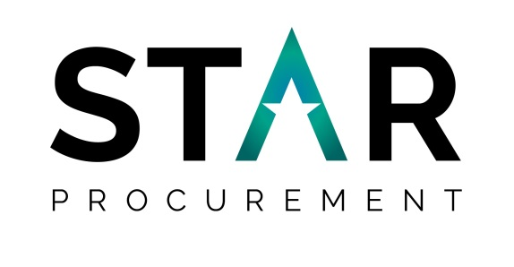
Social Value Case Study
British sign Language

What was the project?

To procure a professional communication support service which incorporates British Sign Language (BSL), Deafblind Interpreters, Lipspeakers Electronic Notetakers and Speech to Text reporters (STTRs).

Project Team  Stockport Council:  Maribel Garcia-Vidal  Darren Grecian  STAR Procurement:  Carla Cooke  Stephanie Jones | - Engage 2 long term unemployed clients with specialist employment & enterprise service each year over the 3 year life of the contract.  - Committed to provide 4 hours per week in support of deaf/deaf blind clients as they seek employment and betterment.  - Commitment to independent Living skills courses, commit to spending £10,000 per annum to spend with local VCSEs over the coming years  - Commit to 100 hours a year through delivery of Deaf Awareness, Basic BSL, Inclusive Employment and Access to Work training for Stockport service providers, in assistance of business/organisational development.  - Commitment to spend at least £9,000 on professional fees to BSL Interpreters based in Stockport local authority area.  All above to be obtained through regular contract management meetings.
How were the Social, Economic & Environmental
Issues (“Social Value”) Addressed?

- During the tender development, the Council was encouraged to consider all strands of the GMCA Social Value policy
- The award criteria was discussed and agreed with the stakeholders and consideration was given as to all TOMS. Social Value was set at 20% of the overall score
Want to know more?  Contact us on either:  (e) procurement@star-procurement.gov.uk  (t) 0161 912 1616 | Lessons Learned  Ensure all bidders are aware of how the portal operates and how calculations are made before tender submission date and time.
Leading transformation through procurement and cooperation

